4.1-4.3 Peripheral Nervous System: Afferent Division

* **Visceral afferent**: from internal organs, mostly subconscious except pain
* **Sensory afferent**: from body surface / muscles / joints, mostly conscious
  + 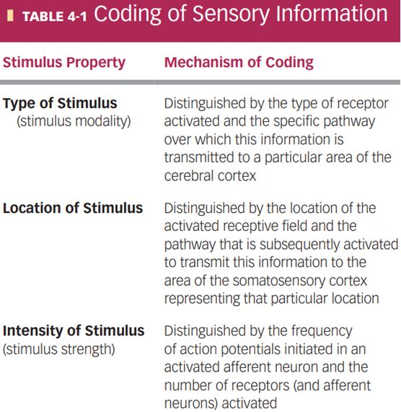**Somatic senses** (body senses, physical) vs **special senses** (vision, hearing, taste, smell, and equilibrium)
* **Sensory receptors** (4 primary types): **thermoreceptors** (heat), **mechanoreceptors** (pressure), **photoreceptors** (light), and **chemoreceptors** (chemicals)
  + **Nociceptors**: only senses pain
  + Receptors can be **specialized ending** of the afferent neuron (stimuli directly triggers Na channels), or a **separate receptor cell** closely associated with the dendrite of the afferent neuron (cell release chemicals like synapse)
    - Both produces graded potential: **generator potential** (if specialized ending) or **receptor potential** (if separate cell)
* **Transduction**: conversion of stimuli to electrical signal (all stimuli are eventually action potentials of the neurons)
  + Distinguish signals through **MILD** (**modality**, **intensity**, **location**, **duration**)
  + **Adequate stimulus**: type of stimuli the receptor responds best to, can respond to other stimuli (create similar respond since **modality of receptor** is the same)
  + Intensity cam be both frequency and number of receptors activated
* **Tonic Adaptation** decrease intensity when stimuli continuously present
  + **Tonic receptors**: do not / mildly adapt (muscle, joints, need continuous signals)
  + **Phasic receptors**: rapidly adapt, respond to change in stimuli (tactile)
* **labelled lines**: chains of neurons in the somatosensory pathway, accomplish progressively more sophisticated processing of the sensory information
  + first-order, second-order, third-order sensory neurons
* **Receptive field**: responsive region, size varies inversely with concentration receptors, smaller field = higher acuity / discriminative ability
* **Lateral inhibition**: inhibitory interneurons between parallel sensory neurons, stronger stimuli inhibit weaker stimuli around it for sharper / finer sensations (touch & vision)
* Tactile mechanoreceptors (5 types):
  + **Pacinian corpuscles**:phasic; heavy touch, rough surface, vibration (250Hz)
  + **Meissner’s corpuscles**: phasic; light touch, vibration (>50 Hz)
  + **Merkel’s discs**:tonic; vibration (5-15 Hz)
  + **Ruffini corpuscles: tonic**; stretch and torque in deep layers of skin
  + **free nerve endings** (most abundant, around hair roots / eyes / other tissues, specialize in touch and pressure, also used for temperature and pain)

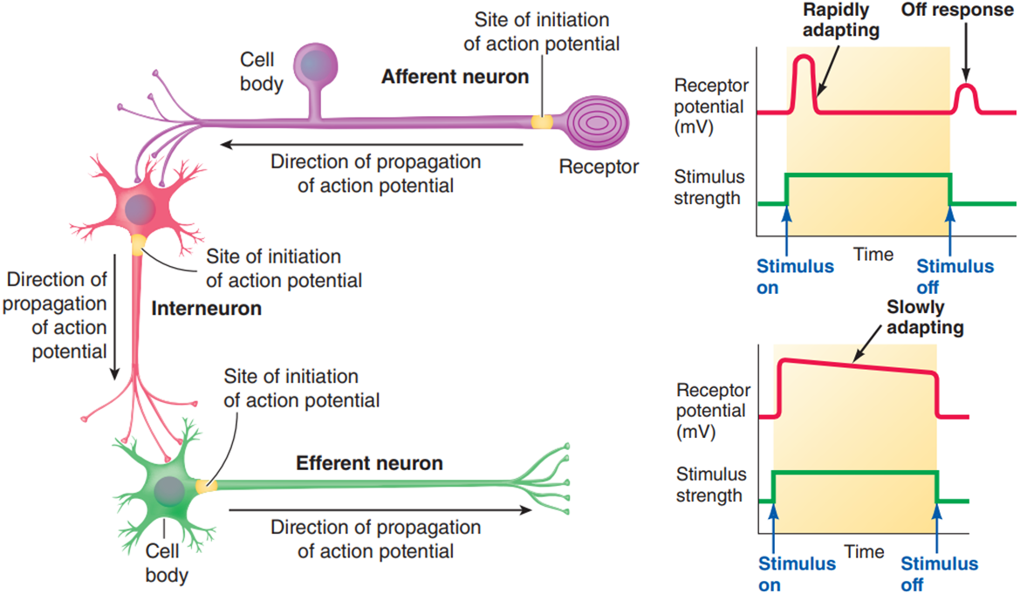

4.8-4.10 Peripheral Nervous System: Efferent Division

* **Acetylcholine** & **norepinephrine**: only two neurotransmitters used by effector neurons
* **Automatic nervous system** (ANS): controls smooth muscles, glands, heart, and gastrointestinal tract; controlled by hypothalamus, brain stem, and spinal cord
  + Autonomic nerve pathways: always a **two-neuron chain**, axon of first neuron (**preganglionic fibre)** synapse with second neuron in a ganglion (neurons outside CNS), axon of second neuron (**postganglionic fibre**) connects with effector organ
  + Postganglionic fibres end in **varicosities**, (numerous swellings / synaptic knobs), release neurotransmitter over a large area (innervate organs rather than cells)
  + 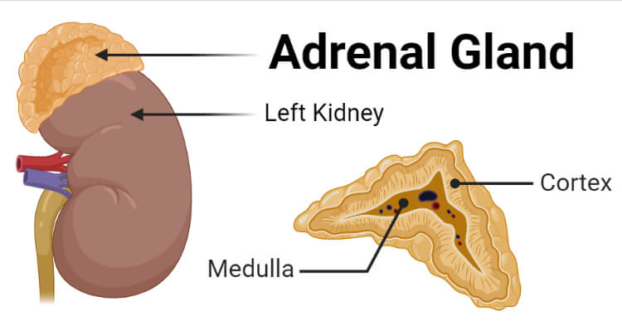**Adrenal medulla**: modified sympathetic ganglion that does not give rise to postganglionic fibres, releases 2:8 norepinephrine and **epinephrine (adrenaline)**
  + **Antagonistic** (stopping one and activating the other, faster, most organs use this) vs **tonic** (control with only one, blood vessels & sweat glands only sympathetic)
  + **Agonists** (bind to same receptor to mimic transmitter) vs **antagonists** (bind to same receptor to block transmitter) drugs
  + CNS control:
    - Spinal cord: autonomic reflexes (urination, defecation, erection), subject to control by higher levels of consciousness
    - Medulla: most directly responsible for autonomic output, centre for controlling cardiovascular, respiratory, and digestive activities
    - Hypothalamus: integrates the autonomic, somatic, and endocrine responses accompanying emotional and behavioural states.
    - Prefrontal cortex: emotional expression of the individual’s personality (?)

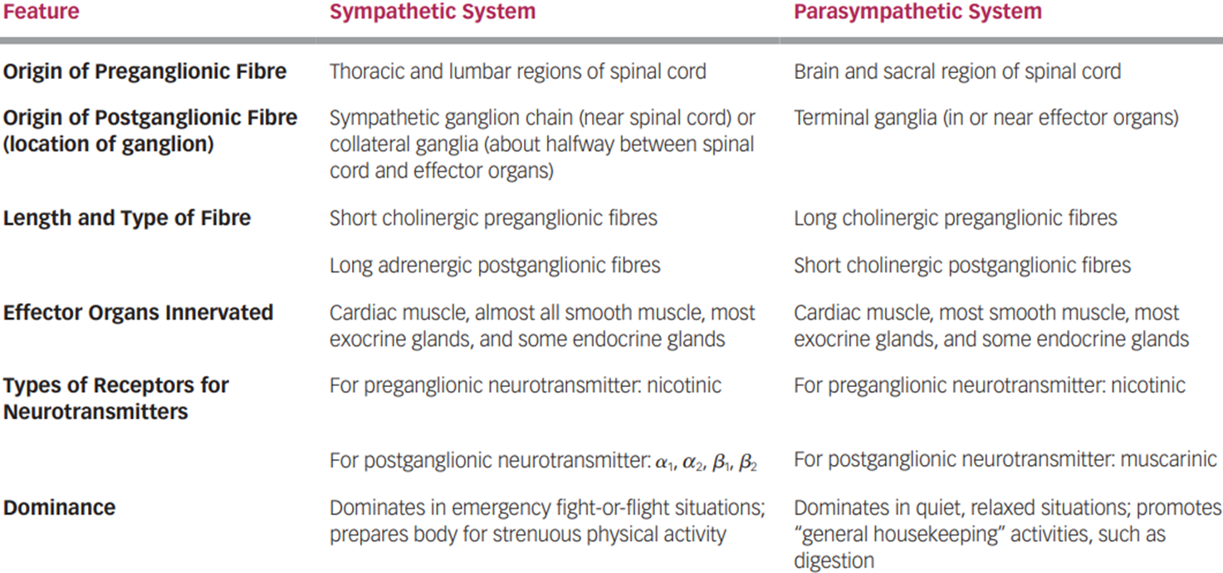

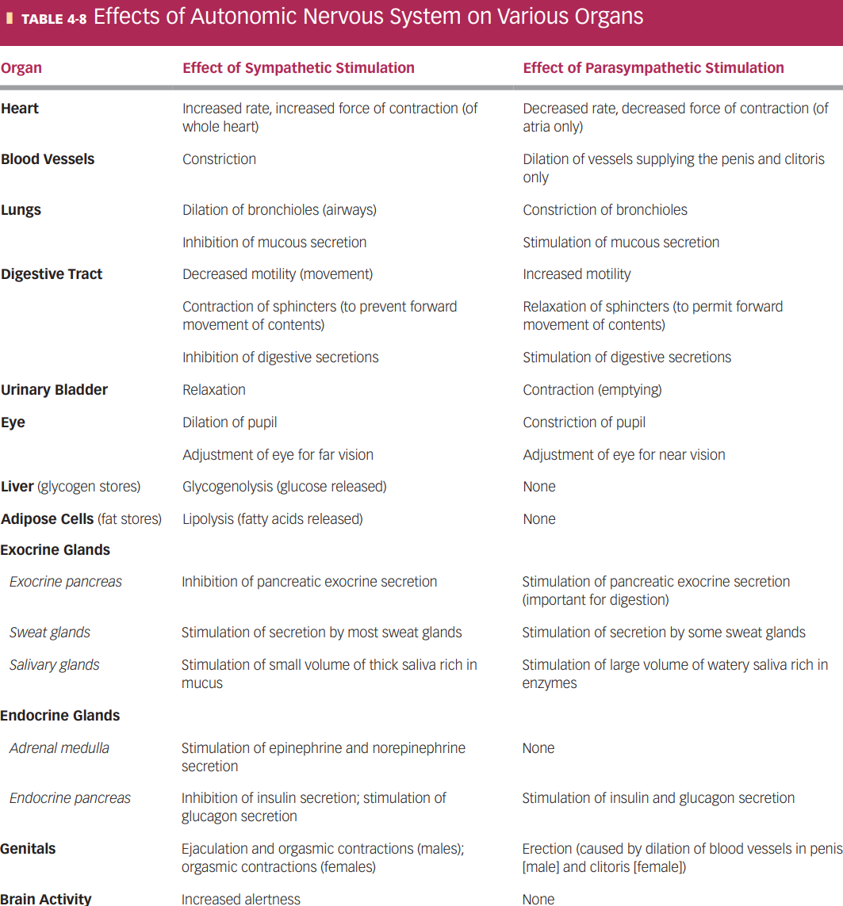

* + Neurotransmitter receptors:
    - Acetylcholine (**cholinergic**) receptors:
      * **Nicotinic**: found on the postganglionic cell bodies in all autonomic ganglia, depolarizes in respond to acetylcholine
      * **Muscarinic**: found on effector cell membranes, respond to acetylcholine released from parasympathetic fibres only
    - 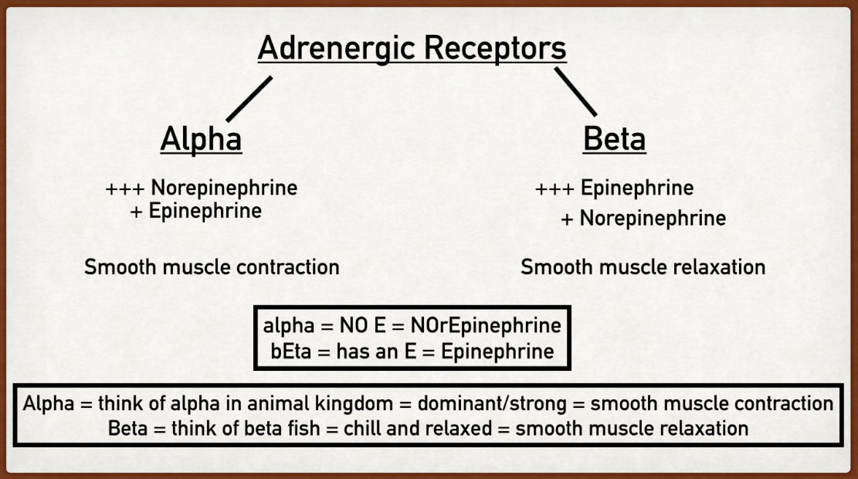**Adrenergic** (catecholamine) receptors: respond to epinephrine and norepinephrine; transfer signal into the cytoplasm, influence metabolic processes and cellular function; , , , , types
* **Somatic nervous system**: motor neurons and skeletal muscle
  + **Motor neurons**:
    - cell bodies in ventral horn (for muscles in head are in brain stem),
    - axon continuous from CNS to end (skeletal muscle)
    - releases acetylcholine – excitation and contraction of muscles
    - can only stimulate muscles but not inhibit
  + **Final common pathway**: only way other parts of the nervous system influence skeletal muscle is by acting on motor neurons
  + Text

    Description automatically generated with medium confidence**Voluntary** but involves subconscious processes (balance and coordination)